A Baseline Assessment of Soil Organic Carbon in the
Mangroves of the Bakassi Peninsula South-West Cameroon
Kamah Pascal Bumtu, Nkwatoh Athanasius Fuashi, Longonje Simon Ngomba
Faculty of Science, Department of Environmental Science, University of Buea, Buea, Cameroon

ABSTRACT
The mangrove soils as one of the global soil types is a major carbon store that helps to curb the rising global temperatures. This is not unconnected to their high carbon storing and sequestration potentials of the peat soils. The conclusion is characterized by some knowledge gaps on the actual carbon stock and sequestration potentials of some mangroves soils on the Central African Sub-regional landscape. Some of these areas are the Bakassi mangroves in the South West Cameroon. Cross-border conflicts, piracy and over exploitation have rendered the sourcing of appropriate data on its carbon stock and sequestration potentials difficult. In strive to bridge this knowledge gap, this work carried out baseline assessments of the carbon stock and sequestration rate of this peat soil. To achieve the study objectives, stratified random opportunistic sampling using an inventory design based on five forest canopy height classes, with collection of peat soils using a soil auger to different depth for laboratory analysis was done. Soils Organic Carbon stocks were estimated from soils to a depth of 100cm and determined using chromic acid digestion and spectrophotometric analysis. Parameters determined were bulk density and percentage carbon. Results showed that; soil carbon stock density ranged from 705.8 (Mg/ha) to 546.2 (Mg/ha). Thus on average, for a hectare in Bakassi, the Soil Organic carbon stock was 632.65 (Mg/ha)

KEYWORDS: Mangrove, Soil Organic Carbon, Carbon Stock, Bakassi Peninsula

How to cite this paper: Kamah Pascal Bumtu | Nkwatoh Athanasius Fuashi | Longonje Simon Ngomba "A Baseline Assessment of Soil Organic Carbon in the Mangroves of the Bakassi Peninsula South-West Cameroon" Published in International Journal of Trend in Scientific Research and Development (ijtsrd), ISSN: 2456-6470, Volume-4 | Issue-3, April 2020, pp.414-421, URL: www.ijtsrd.com/papers/ijtsrd30515.pdf

IJTSRD30515

Copyright © 2020 by author(s) and International Journal of Trend in Scientific Research and Development Journal. This is an Open Access article distributed under the terms of the Creative Commons Attribution License (CC BY 4.0) (http://creativecommons.org/licenses/by/4.0)

INTRODUCTION
In mangroves, soil characteristics are major factors limiting growth and distribution of plants with a resultant an impact on the soil organic carbon. The assertion that mangroves have about 5 times higher carbon stock than terrestrial forests (Ajonina, 2018) could strongly be supported by the high percentage of its soil organic carbon which is the largest pool that characterise mangrove soils (Stringer et al., 2015). The soils are formed by the accumulation of sediment derived from coastal or river bank erosion, or as eroded soils from higher areas transported downstream along rivers and canals. Also, some may originate from the sedimentation of colloidal materials and particulates. These sediments that have accumulated along the coast and in mangroves have different characteristics, depending on their origin. The process of restoration of the Soil Organic Carbon pool, through absorption of atmospheric carbon dioxide (CO₂) by plants growing through photosynthesis into humus is called soil Carbon sequestration (McKinsey et al., 2009). With a high percentage of organic matter and a deep profile, they have a loam or ‘loam/clay soil texture with varying characteristics that result to different percentages of soil organic carbon stock. With these, mangrove importance is very alarming and influential, providing goods and services like; food, construction materials, water purification and pollution control, important carbon sinks, protection of coastal communities from tropical storms, breeding and spawning ground for fishes, nesting sites for migratory birds (Ajonina, 2008). Degrading their soils means reducing these
important potentials. Findings from" Estimate Global Blue Carbon" shows that devastating the ecosystem will cost $6.42 billion in economic damages and the emissions they release will equal 3.19% of emissions that comes from deforestation globally (Duke, 2007). This will lead to an estimated 5.15% of species to be extinct by 2021 (WCED 1992, 2001).These degradation exposes the soils with implications of increasing emissions. The series of climate related hazards that the world have witness in recent times speaks volumes of the consequences of increasing emissions thus spurring the quest for research as well as efforts on the role of peat soil on organic carbon stock and sequestration to mitigate climate change. The world soils comprise the third largest global carbon pool after the oceanic pool of about 38000 Pg and the geologic/fossil carbon pool of ~5000 Pg. This pool is estimated at about 2500 Pg, which has two distinct but related components: (i) the soil organic carbon (SOC) pool of about 1550 Pg, and (ii) the soil inorganic carbon (SIC) pool of about 950 Pg. Often estimated to a depth of 1m, the total soil organic carbon pool of about 2500 is about 3.2 times the atmospheric pool of about 780 Pg, 40 times the biotic pool of about 620 Pg, and about 1.8 times the terrestrial pool of about 1400 Pg which is equal to combined atmospheric and biotic pools put together. The rate of depletion of the soil organic carbon (SOC) pool under agricultural activities is therefore precipitated by soil degradation processes such as accelerated erosion by either water or wind (WMO, 2008; IPCC, 2007). The rate and magnitude of depletion of SOC pool are also accelerated by removal of crop residues and uncontrolled grazing (Lal, 2004). The objective of the study was to carry out a baseline assessment of the SOC stock and sequestration potential of the Bakassi mangroves. This will set the pace for the block by block assessments at the country level for effective carbon pricing. Faced with impacts like increasing; rainfall with variability and unpredictability, droughts, floods, hailstorms, hot days and heat waves, temperatures with ripple effects on the environment and livelihood sectors especially in the more vulnerable African countries with weaker; economies, and technologies (MINEPDED-NAPCC, 2015) and virtue of the high; exposure, sensitivity and low adaptive capacity, redoubling efforts to mitigate this is unavoidable.

MATERIALS AND METHODS
Study Location
This study was carried around the mangroves of the Bakassi Peninsula particularly in Ndian Divisions South-West Region of Cameroon, a biodiversity hotspot that supports high diversity of animal and plant species (MINEPDED, 2009).The work touched 7 mangroves subdivisions (Bamuso, Ekondo Titi, Mundemba, Isangele, Kombo Abedimo, Kombo Itindi and Idabato), between latitudes 4°25′E and 5°10′N and longitudes 8°20′E and 9°08′N (GEF, 2016). Here, strong ocean waves work against the incoming river current to precipitate deposits in the form of large inter-tidal mud or sand flats which favours the growths and establishment of mangrove tree species at this interface. The climate is equatorial and littoral types with two distinct seasons: a short dry season of 4 months (November to February) and a long rainy season almost 8 months (from March to October). The average rainfall ranges from 5000 mm to 10000 mm with July, August and September been the wettest months. Relative humidity is very high, above 85%. The main annual temperature is from 25.5 ⁰C to 27⁰ C (GEF, 2016). The average tides waltz between 0.1 m to 2.9 m accompanied very often by scorching heat waves sometimes going up to 45 ° in the shade (Ocholi, 1986).

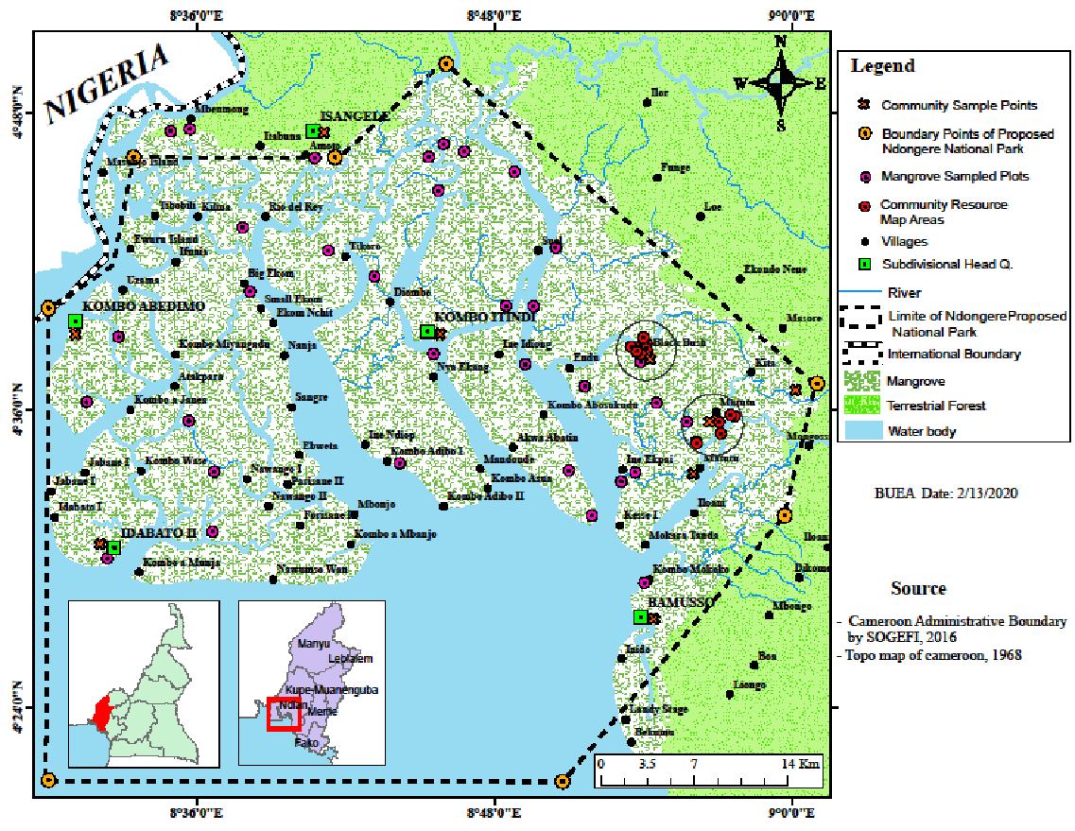
Figure: 1. map of Bakassi Peninsula

With a low elevation of 0 – 2m above sea level (Smoak et al., 1999) the area is predominantly mangroves both indigenous and foreign species (Fig. 1) with Rhizophora racemosa, dorminating (Buh et al., 2019) other indigenous mangroves whilethe exotic Nypa fructicans has colonize a large proportion of the Peninsula. The soils rang from; sandy, ferralitic, to claylike or peat that are generally formed by the deposition of plant particles on watery soils (Smoak et al., 1999).with very old and deeply weathered bedrock, the soils are depleted of nutrients (Bond, 2010) following leaching after heavy rains (Wong & Rowell, 1994). Avi-fauna include; migratory lesser flamingo (Phoeniconaias minor) and the Rachel᾽s Malimbe i.e. Malimbicus racheliae (Ajonina et al., 2004), marine Otter and West African manatee (Trichechus senegalensis) Giant frog, Dwarf crocodile (Osteolaemus tetraspis) and Conraua goliath (Sarmiento and Oates, 2000, Sunderland-Groves et al, 2003, Bergl and Vigilant, 2007), some mangrove phytoplankton identified are; Bacilliophyceae, Dinophyceae and Cyanophyceae (GEF, 2016)

This area is sparsely populated (about 150,000 to 300,000 inhabitants ) by ethnic groups from Nigeria and Cameroon (Ejaghams and the Efiks) where about 70% of the population comes from Nigeria (Guilleune et al., 2017).Their primary economic activity is fishing, farming for subsistence needs and timber harvesting which is limited to artisanal tree cutting. Also, the area has rich oil reserves in neighboring areas of Nigeria (GEF, 2016) where off-shore oil exploitation has been going on since 1960, accounting for over 70% of Cameroon’s oil production

METHODS
Field survey
Stratified random and opportunistic sampling was used to identify and establish plots. This permitted better accuracy, precision and efficiency due to the heterogeneous nature of the forest and its functional reliability. Also, the necessity to capture relevant variables in the equations coupled to the fact that the area was finite or known as recommended in Kauffman and Donato (2012), Asseffa et al., (2013) gave preference to this method. Stratification criteria took in to account; tree height and nature of forest (intact, degraded, and highly degraded) while the sampling area took in to account the species, cost, security conditions, accessibility (nature of soil, tides). Digital Elevation Model (DEM) of the Radar Topographic Mission (SRTM) model was used to differentiate height ranges where the use of mangroves height data was the basics for stratification. Five classes were distinguished (Tab. 1) using geometric interval breaks which is a compromise method between equal interval, natural breaks (Jenks), and quantile (Carl et al., 2015)

Table1: Mangrove canopy height classes delineated through analysis of SRTM data
Class ID | Height
1 | 0-8
2 | 8.1-11
3 | 11.1-15
4 | 15.1-19
5 | ≥19.1
Adapted from Buh et al., 2019

Square plots of 20m x 20m (40 in number) were established on a selected stratum to get data as in Jones (2014) at the center of the plots. These Plots were establishment with the help of a 50 m transect tape (Tibre ). A compass (silva Polaris) was used to get the plot bearings and a Garmin GPS (Map 62) was used to collect geographical coordinates for the locations of the plots. The plot centers were identified using the transect tape and marked with a GPS for collection of soil samples. Soil samples were collected at the center of the plots, inside the 10m x 10 m subplots (Fig.2). The soils were sampled to a depth of 1m using an open gouge auger. The collection interval were 0cm-60cm, 60cm-80cm and 80cm-100cm (Buh et al., 2019). Before the samples were collected, organic litter were removed from the soil surface, at the point of collection.

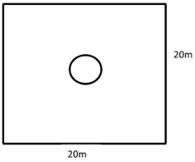
Figure2. Plot design for soil sample collection in Bakassi Mangroves
The soil auger was pushed into the ground and at 1m interval, it was twisted at least 5 times clockwise to collect soil core as recommended in Kaufman and Donato (2012). Soil samples of approximately 5cm were removed at the require interval (Tab. 3) on the auger using a knife and the samples placed in pre- labeled sealable plastics. These intervals were measured with the help of a ruler to the nearest mm.

Table3: Soils layers represented by samples and the sampling Intervals for each soil core
Soil ID | Sample depth (cm) from surface | Sample interval(cm)
1 | 0-60 | 55-60
2 | 60-80 | 75-80
3 | 80-100 | 95-100
Where obstacles were encountered, the auger was removed, cleaned and location changed.

The soil samples were preserved sealed in air tight plastic bags to ensure safety during transportation and to reduce microbes on the wet soil. The samples were prepared for the laboratory by making an inventory list to link numbering schematics used on the field with sample information like plot number and soils sampling depths. They were later taken to the laboratory for drying and analysis for bulk density and percentage carbon as recommended in Stringer et al., (2015)

At the laboratory, samples were air dried and later oven dried at a temperature of 105°C for 48 hours till a constant dry mass was attained. Samples were grinned and sieved through a 2 mm sieve. The grinding speeded up and improved the drying process and equally eased sieving. This was relevant for calculating the bulk density. For carbon analysis; soils were further fine grind and sieved through a 0.5 mm sieve. Organic carbon was then determined by chromic acid digestion and spectrophotometric analysis (Heanes, 1984). To control the quality, there was inclusion of four external reference samples and a certified sample from International soil exchange program in every batch analyzed.

For the data analyses; the soil bulk density was gotten by dividing the sample dry mass in grams by its volume (cm⁻³) for each soil core.

Soil bulk density (gcm⁻³⁾ = Oven dry mass (g) Sample vol ( cm⁻³⁾……………………Kaufman and Donato (2012)

The soil organic carbon (Mg/ha) per sampled depth interval = Bulk density (gcm⁻³) * Soil depth interval (cm) * % C…………………………………………………Kaufman and Donato (20120)

Where % C, is the percentage Carbon concentration expressed as a whole number.

The total plot soil carbon was then determined by summing the carbon mass of each sampled soil depth interval (0cm -60cm, 60cm-80cm, 80cm-100cm) in Mg C/ha

Data collected from the laboratory were verified for accuracy and quality, inputted in to the spread sheets, classified in to their respective height classes following the stratification and further imported into MINITAP version 19.0 and the findings presented in a simple and understandable way for all potential readers using charts and graphs as described in Djomo (2015). Variables like the standard error of the mean in the carbon stock gotten was the standard deviation to the true mean of all the different means from the population (Tesfaye &Astrat (2013) while the standard deviations was taken as the square root of the variance, variations were the average of the squared deviations between each data thus, the mean was sum of all the values of the variable divided by the total as recommended in Yeomans (1968)

FINDINGS AND ANALYSIS
Organic soil carbon stock contributes to a high proportion of the total ecosystem carbon in mangroves. This is gotten through investigations of a number of variables such as the bulk density, the percentage carbon and the depth of the soil layer or sample (Tab 4)

Table4: Variation of Bulk density, %C and Mean SOC per depths with height class
 |  | Bulk density(g/cm³) |  | %C |  | Carbon density(Mg/ha)
Height Class | Soil Depth | Mean | SE± | Mean | SE± | Mean | SE±
1 | 0-60 | 0.77 | 0.10 | 9.90 | 2.05 | 469.83 | 126.32
1 | 60-80 | 2.83 | 0.11 | 9.40 | 2.32 | 133.96 | 42.29
1 | 80-100 | 0.62 | 0.07 | 8.93 | 2.02 | 101.98 | 17.81
2 | 0-60 | 1.02 | 0.37 | 27.83 | 17.42 | 2281.55 | 2018.34
2 | 60-80 | 1.20 | 0.45 | 26.98 | 17.92 | 885.79 | 808.12
2 | 80-100 | 1.00 | 0.29 | 27.19 | 17.79 | 701.97 | 606.09
3 | 0-60 | 0.78 | 0.04 | 10.51 | 0.60 | 503.90 | 44.19
3 | 60-80 | 0.74 | 0.04 | 10.02 | 0.66 | 150.53 | 13.55
3 | 80-100 | 0.60 | 0.05 | 9.91 | 0.65 | 119.35 | 12.74
4 | 0-60 | 0.78 | 0.06 | 13.26 | 2.38 | 875.99 | 299.36
4 | 60-80 | 0.77 | 0.08 | 13.09 | 2.40 | 315.18 | 118.07
4 | 80-100 | 0.76 | 0.04 | 12.28 | 2.42 | 247.64 | 78.52
5 | 0-60 | 0.61 | 0.01 | 8.91 | 1.79 | 329.19 | 68.37
5 | 60-80 | 0.71 | 0.11 | 8.53 | 1.69 | 120.86 | 27.76
5 | 80-100 | 0.53 | 0.02 | 9.01 | 2.19 | 96.20 | 24.03

Bulk density
Across the sampled plots, mean soil bulk density at the upper layer ranged from 0.61 (gcm⁻³) in height class 5 to 1.0 (gcm⁻³) in height class 2. Within the middle layers, it ranged from 0.71gcm⁻³ in class 5 to 2.83gcm⁻³ in class 2.At the deeper layer; it ranged from 0.54gcm⁻³ in class 5 to 1.0gcm⁻³ in class 2. The maximum values were within the middle levels, the upper and reduced as the depths increased. This changes where however irregular (Tab. 4). Generally, mean bulk density witnessed an irregular trend, increasing from 0.67(g/cm³) at the 0cm- 60cm depth to 0.67(g/cm³) at the 60cm-80cm depth and decreased to 0.53(g/cm³) at the 80cm-100cm depth (Fig. 2)

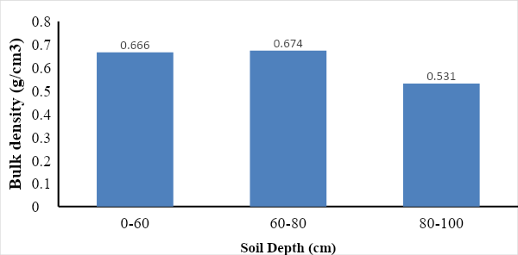
Figure2: Bulk density according to soil depth in Bakassi

Average Percentage Carbon
Across the different height classes, percentage carbon in the different depths varied. At the upper level (0cm-60cm), it ranged from 8.91%C in height class 5 to 27.83%C in height class 2. In the middle (60cm-80cm), it ranged from 9.01% C in height class 5 to 27.00 in height class 2. At the deeper level (80cm-100cm), it ranged from 9.01%C in class 5 to 27.20%C in class 2 (Tab 4). The average percentage carbon did change with increasing depth where, it decreased from 9.54 % at the 0cm-60cm depth to 9.33% at the 60cm-80cm depth and to 9.13% at the 80cm-100cm depth (Fig. 3). Generally, the trend showed a steady decrease for the average percentage carbon.
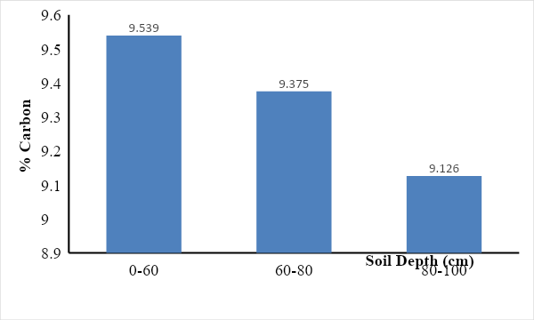
Figure3: Percentage carbon (%) according to soil depth in Bakassi

Mean carbon density
Across the different height classes, the mean carbon densities in the different depths varied. At the upper level (0cm-60cm), it ranged from 329.19C (Mg/ha) in height class 5 to 2281.60C (Mg/ha) in height class 2. In the middle (60cm-80cm), it ranged from 120.90C (Mg/ha) in height class 5 to 885.80C (Mg/ha) in height class 2. At the deeper level (80cm-100cm), it ranged from 96.20C (Mg/ha) in class 5 to 702.00C (Mg/ha) in class 2 (Tab. 4). Generally, the trend for the mean carbon density decreased with depth from 400.24 (Mg/ha) at the 0cm-60cm depth to 128.61 (Mg/ha) at the 60cm-80cm depth and to 109.14 (Mg/ha) at the 80cm-100cm depth (Fig. 4)

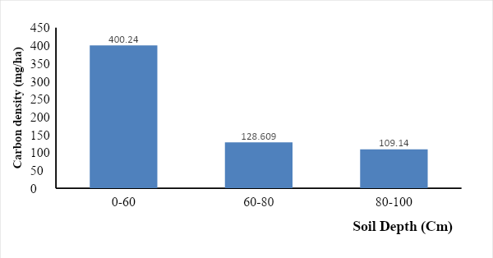
Figure4. Carbon density according to soil depth in Bakassi Generally, there was a regular and decreasing trend with depth in this area.

Ecosystem Soil Organic carbon (SOC)
Carbon densities within soil depths were added to get the ecosystem soil organic carbon density (Mg/ha) for every height class in each of the study areas. This was a sum of the different mean carbon stock for the different soil depths up to 1m within the different height classes.

Total soil Carbon density
The soil carbon values ranged from 546.35(Mg/ha) in height class 5 to 773.78 (Mg/ha) in height class 3.The trends however were irregular within the different height classes.
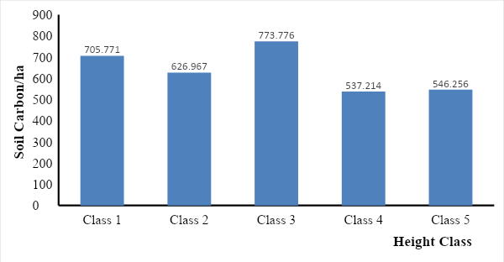
Figure5: Variation of total Soil Organic Carbon

Average carbon stock per height class
Average soil organic carbon stock per height class ranged from 75.24 (Mg/ha) in height class 2 to 257.87 (Mg/ha) in height class 5. The values increased in a regular manner from height class 1 to 5.

Average Per hectare carbon for the areas
Table6: Average carbon per hectare in Bakassi
Height class | Total Carbon Stock-(Mg C/ha) | Area(ha) | Total Carbon/Class height(Mg/ha)
1 | 705.77 | 0.16 | 112.92
2 | 626.97 | 0.12 | 75.24
3 | 773.78 | 0.32 | 247.61
4 | 537.21 | 0.48 | 257.86
5 | 546.26 | 0.12 | 65.55
Total |  | 1.2 | 759.18
Av. Mg/ha |  |  | 632.65
Thus on average, for a hectare in Bakassi, the soil organic carbon stock is 632.65 (Mg/ha)

DISCUSION
Inventory Design
A rectangular sampling design was adapted with lessons from Jones, 2014; Buh et al., 2019; kaufman and Donato (2012). This design was preferred because the area had a lot of small creeks and Islands as well as for better quantification, accuracy and precision of the desired results. Thus; trampling was reduced, accessibility was enhanced and sampling consistent in all plots irrespective of the species in the area. This approach was different from the circular plots recommended by Murdiyarso et al., (2009), Kauffman and Donato (2012) in the Indo-pacific mangroves.

Bulk density
Bulk density is an indicator of soil compaction and could be relevant in determining the relationships between soil particle size distribution and organic matter content.Changes in bulk density could be caused when activities modify the soils. The nature of variation in bulk density in this area is due to the soil type and basement rock, given that the Bakassi mangroves are made up mostly of soft muddy soils (Buh et al., 2019). The coastline is mostly muddy with a few areas been sandy especially when approaching the southern parts or the Cameroon Estuaries.

Average percentage carbon
Average percentage carbon is influenced by different factors amongst which are; high productivity and low decomposition rate of the wetland (Enong, 1993) as well as superior hydrothermal conditions and periodic flooding by tides which inhibits aerobic respiration and reduces the rate of decomposition of organic matter, subsequently leading to high organic carbon storage (Twilley, Chen, and Hagis, 1992). In this area it had higher concentration of sediments that came from the difference numerous stream currents occurring the area (Buh et al., 2019).

Mean SOC density
The carbon density within the area is of paramount important to most assessments given that it is an unavoidable variable and is influenced by its rate of carbon recycling. Like the percentage carbon, this is due to the vegetation cover, the sediments that are carried in to the area from the tidal inundations, streams flowing in to the area as well as the rate of decomposition of sediments in the area.

Ecosystem carbon
Ecosystem Soil Organic Carbon stock was a sum of all the soil organic carbon densities of the different soil depths

Total Soil Organic Carbon
The total soil carbon in the mangroves may vary from place to place depending on the rate of sedimentation, the amount of carbon release or the level or rate of forest disturbance or biomass removal, the percentage of stem density, the depth of the soil and the bulk density. In this area, the total soil organic carbon (546.35Mg/ha to 773.776Mg/ha) between the plots was a little higher than the values (containing 274.6.7 Mg/ ha to 279.6 Mg/ ha) recorded by Stringer et al., (2015) while studying the mangroves around the Zambezi mangroves. These values resulted from interplay between the amounts of biomass removal, the rate of carbon stock formation, the rate of diverse threats witnessed given that the constant harvesting of the forest lead to less litter and other organic matter left for decomposition and increase of the peat soil. The rate of sedimentation equally depended on the wave movements and stream flow in to the area. Also, the bulk density of this area played much on the total soil organic carbon stock. Summarily, the carbon content, climate, topography, soil type, microbial communities, nitrogen cycling process, management, and land use (Murty et al., 2002) are amongst the factors cited by Ziegler et al., (2012) to account for the factors affecting SOC while Wang et al., (2013) also discovered that forest organic carbon density increases with biomass growth and stand age of the mangrove forests. Similar results were obtained by Gleason and Ewel (2002) in their study of a Micronesian mangrove forest, as well as by Sun (2011) and Zhang et al. (2012) in their studies of a mangrove forest in Southern China. Sun (2011) also reported that the soil organic carbon in mature forest (105.73 t/ha) was higher than that in young (74.43 t/ha) and middle-aged mangrove forest (87.69 t/ha).

Total Ecosystem Carbon density (TEC)
The total ecosystem soil organic carbon soil is often the summation of the different depth organic soil carbon stocks. In this study site like elsewhere in the world, vegetation types and shifts in the coverage of dominant plants exerts a major influence on C fluxes (Andresen et al., 2016 and Niu et al., 2010), though differences in values could be due to the difference in vegetation cover, soil conditions, threats, soil and climatic conditions.

Thus, average per hectare soil organic carbon was 632.65Mg/. This values are larger than the (454.92Mg C/ha and 340.87MgC/ha) reported by Benson et al., (2017) for the assessment of open and closed canopy mangrove respectively in S-W Madagascar. Also, the values are lower than the mean value (799MgC/ha) reported by kaufman and Bhomia (2017) for the entire poles of the mangroves of West-Central Africa as well as the global values (885MgC/ha) for mangroves.

Recommendation
Proper land use practices have to be implemented in the area as well as sustainable land and forest management practices.

CONCLUSION
The quantities for the mean organic soil carbon stock density per hectare in Bakasssi mangroves ranged from 537.22 Mg C/ha to 773.78Mg C/ha and for the different height classes. Thus average per hectare SOC was 632.65MgC/ha.

Acknowledgement
The authors are grateful to Pr. Ayonghe Samuel Ndonwi Of the University of Buea for taking time off to review this article.

Reference
- Ajonina G., Diamé A., Kairo J. (2008). Current status and conservation of mangroves in Africa: An overview. World Rainforest Movement Bulletin No. 133 6pg
- Ajonina, (2018).Presentation on climate change vulnerability assessment and adaptation planning in WWF-Cameroon Workshop in Douala
- Ajonina, G.N., Ayissi, I. and Usongo, L. (2004). Inventory of Coastal Wetlands of Cameroon/Inventairedes Zones Humides Côtieres du Cameroun. Wetlands International Report. 68pp.
- Alan D. Ziegler, Jacob Phelps, Jia QI Yuen, Edward L. Webb, Deborah Lawrence, Jeff M. Fox, Thilde B. Bruun, Stephen J. Leisz, Casey M. Ryan, Wolfram Dressler, Ole Mertz, Unai Pascual, Christine Padoch, Lian Pin Koh (2012). Carbon outcomes of major land‐cover transitions in SE Asia: great uncertainties and REDD+ policy implications: Global Change Biology.
- Alongi, D. M. (2011). Carbon payments for mangrove conservation: Ecosystem constraints and uncertainties of sequestration potential. Environ. Sci. Policy 14, 462–470. [CrossRef]
- Alongi, D. M., (2002). Present state and future of the world’s mangrove forests. Environ. Conservation 49
- Andresen, C. G, Lara MJ, Tweedie CE, Lougheed V.L. (2016). “Rising plant-mediated methane emissions from arctic wetlands”. Global Change Biol. 23: 1128–1139.
- Assefa, G., Mengistu, T., Getu, Z., & Zewdie, S. (2013). Training manual on: Forest carbon pools and carbon stock assessment in the context of SFM and REDD+. Wondo Genet, Ethiopia: Wondo Genet College of Forestry and Natural
- Asrat, Z., & Tesfaye, Y. (2013). Training manual on forest inventory and management in the context of SFM and REDD+. Hawassa: Hawasa University.
- Benson, L., Glass L., Jones,T.G., Ravaoarinorotsihoarana, L., and Cicelin Rakotomahazo, C.(2017). Mangrove Carbon Stocks and Ecosystem Cover Dynamics in Southwest Madagascar and the Implications for Local Management. Forests 2017, 8, 190; doi: 10.3390/f8060190
- Bergl, A. and Vigilant, L. (2007); Genetic analysis reveals population structure and recent migration within the highly fragmented range of the Cross River gorilla (Gorilla gorilla diehli). Blackwell Publishing Ltd
- Bond-Lamberty, B. & Thomson, A. (2010). Temperature-associated increases in the global soil respiration record. Nature, 464(7288), pp. 579-82. Available at: http://www.ncbi.nlm.nih.gov/pubmed/20336143 [Accessed June 15, 2011].
- Buh, G., Bumtu K.P., Meh, A. and Nsobih, M. (2019); Space-based spacio-temporal mangrove forest dynamics and carbon stock assessment: the Ndongere mangrove, Southwest Cameroon OSFACO.WWF Cameroon.
- Carl C. (2005). Compsition, biomass and structurof mangroves within the Zambezi River Delter pg 184
- Djomo, A., (2015).Climate Change Mitigation. Forest Ecosystems: Measurement and Modelling of Biomass and Carbon. IFED publishing.
- Donato, D. C.; Kauffman, J. B.; Murdiyarso, D.; Kurnianto, S.; Stidham, M.; Kanninen, M. (2011). Mangroves among the most carbon-rich forests in the tropics. Nat. Geosci. 4, 293–297. [CrossRef]
- Duke, N. C., Meynecke, J. O., Dittmann, S., Ellison, A. M., Anger, K., Berger, U., Cannicci, S. Diele, K., Ewel, K. C., Field, C. D., Koedam, N., Lee, S.N., Marchand, C., Nordhaus, I., and Dahdouh-Guebas, F. (2007). Ethnobiol Ethnomedicine 2: 1746-4269. 2007.Importance of mangroves of the East-Godavari Delta (Andhra Pradesh, India) for conservation and management purposes
- Eong, J. E. (1993). “Mangrove-a carbon source and sink”
- Giri, C.; Ochieng, E.; Tieszen, L.L.; Zhu, Z.; Singh, A.; Loveland, T.; Masek, J.; Duke, N. (2011)Status and distribution of mangrove forests of the world using earth observation satellite data. Glob. Ecol. Biogeogr., 20, 154–159. [CrossRef]
- Gleason SM, Ewel K.C. (2002). Organic matter dynamics on the forest floor of a Micronesian mangrove forest: an investigation of species composition shifts. Biotropica 34: 190–198.
- Global Environment Facility (GEF), (2016); Cameroon: Participative Integrated Ecosystem Services Management Plans for Bakassi Post Conflict Ecosystems PINESMAP BPCE. www.TheGEF.org
- Heanes, D. L. (1984). Determination of Total Organic C in Soils by Improved Chromic Acid Digestion and Spectrophotometric Procedure. Communications in Soil Science and Plant Analysis, 15(10): 1191-1213
- IPCC, (2007). Climate Change 2007. The Fourth Assessment Report. The Physical Science Basis. Cambridge, United Kingdom, Cambridge University Press.
- Jones, T.G. (2014). Building the Case for Blue Carbon in Madagascar. In The Abu Dhabi Blue Carbon Demonstration Project. Building Blue Carbon Projects – An Introductory Guide. AGEDI/EAD,(2014).Published by AGEDI. Produced by GRID- Arendal, A Centre Collaborating with UNEP, Norway
- Kauffman JB, Bhomia, R. K. (2017).Ecosystem carbon stocks of mangroves across broad environmental gradients in West-Central Africa: Global and regional comparisons. PLoS ONE 12(11): e0187749. https://doi.org/10.1371/journal.pone.0187749
- Kauffman, J., & Donato, D. (2012). Protocols for the measurement, monitoring and reporting of structure, biomass and carbon stocks in mangrove forests. Center for International Forestry. Bogor, Indonesia
- Lal, R. 2004a. Soil carbon sequestration impact on global climate change and good security. Science 304: 1623- 1627.
- McKinsey & Company. 2009. Pathways to a low carbon economy. Version 2 of the global greenhouse gas abatement cost curve. London, U.K.
- Ministère de l’environnement de la protection de la nature et du développement durable (MINEPDED) 2009
- Ministère de l’environnement de la protection de la nature et du développement durable (MINEPDED) 2015. Cameroon National Adaptation Plan for Climate Change(NAPCC)
- Murdiyarso, D., Donato, D., Kauffman, J. B., Kurnianto, S., Stidham, M.,& Kanninen, M. (2009).Carbon storage in mangrove and peatland ecosystems. A preliminary account from plots in Indonesia (No.CIFOR). Indonesia
- Murty, D.(2002). Does conversion of forest to agricultural land change soil carbon and nitrogen? a review of the literature. Global Change Biology, 8(2), pp. 105-123. Available at: http://doi.wiley.com/10.1046/j.1354-1013.2001.00459.x.
- Niu S, Wu M, Han YI, Xia J, Zhang ZHE, Yang, H. (2010) “Nitrogen effects on net ecosystem carbon exchange in a temperate steppe”. Global Change Biol.; 16: 144–155.
- Ocholi, R. and Okoh, A.E.J. (1986). A Fatal Case of Pasteurellosis in a Patas Monkey in Jos Zoo, Nigeria
- Sarmiento, E. E., & Oates, J. F. (2000). The Cross River gorillas: a distinct subspecies, Gorilla gorilla diehli Matschie 1904. American Museum Novitates, 2000(3304), 1-55.
- Smoak, J.M. (2012). Sediment accretion and organic carbon burial relative to sea-level rise and storm events in two mangrove forests in Everglades National Park, Catena http://dx.doi.org/10.1016/j.catena.2012.10.009
- Stringer, E.C, Carl, C.T, Jones, T.G, Glass L., Lalao, R., Raherindray, R. (2015). Mangrove Carbon Stock Inventory: field methods
- Sun P. G. (2011) .Identification of conserved protein complexes by module alignment. Int J Data Min Bioinform 5(6):593-610
- Sunderland-Groves, J. L., & Maisels, F. (2003). Large mammals of Takamanda Forest Reserve, Cameroon. Takamanda. The Biodiversity of an African Rainforest, 111-127.
- Twilley, R. Chen, R. and Hagis, T. (1992) “carbon sinks in mangrove forest and their e carbon budget of tropical coastal ecosystem”
- Wang, G., Guan, D., Peart, M. R., Chen, Y., Peng, Y. (2013). Ecosystem carbon stocks of mangrove forest in Yingluo Bay, Guangdong Province of South China. Forest Ecol. Manage. 310, 539-546.
- WCED (1992) our common future reconvened. London,
- WMO, (2008); World Meteorological Organization (WMO). 2008. Guide to Hydrological Practices, Vol. I: Hydrology – From Measurement to Hydrological Information. Sixth edition. Geneva, Switzerland: WMO No 168.
- Wong M. T. F. & D. L. Rowell. (1994). Leaching of nutrients from undisturbed lysimeters of a cleared Ultisol, and Oxisol collected under rubber plantation and Inceptisol. Interciencia 19(6): 352-355.
- Yeomans, K. A. (1968), ‘’Statistics for the social Scientist. Vol. 2, Applied Statistics’’, Penguin, London.
- Zhang L, et al. (2012) Expulsion of selenium/protein nanoparticles through vesicle-like structures by Saccharomyces cerevisiae under microaerophilic environment. World J Microbiol Biotechnol 28(12):3381-6

